Direct Membership Application Form
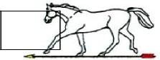 | Dorset & Wiltshire Archery Association

2020 / 2021
Please complete the form, and send with attachments and cheque to
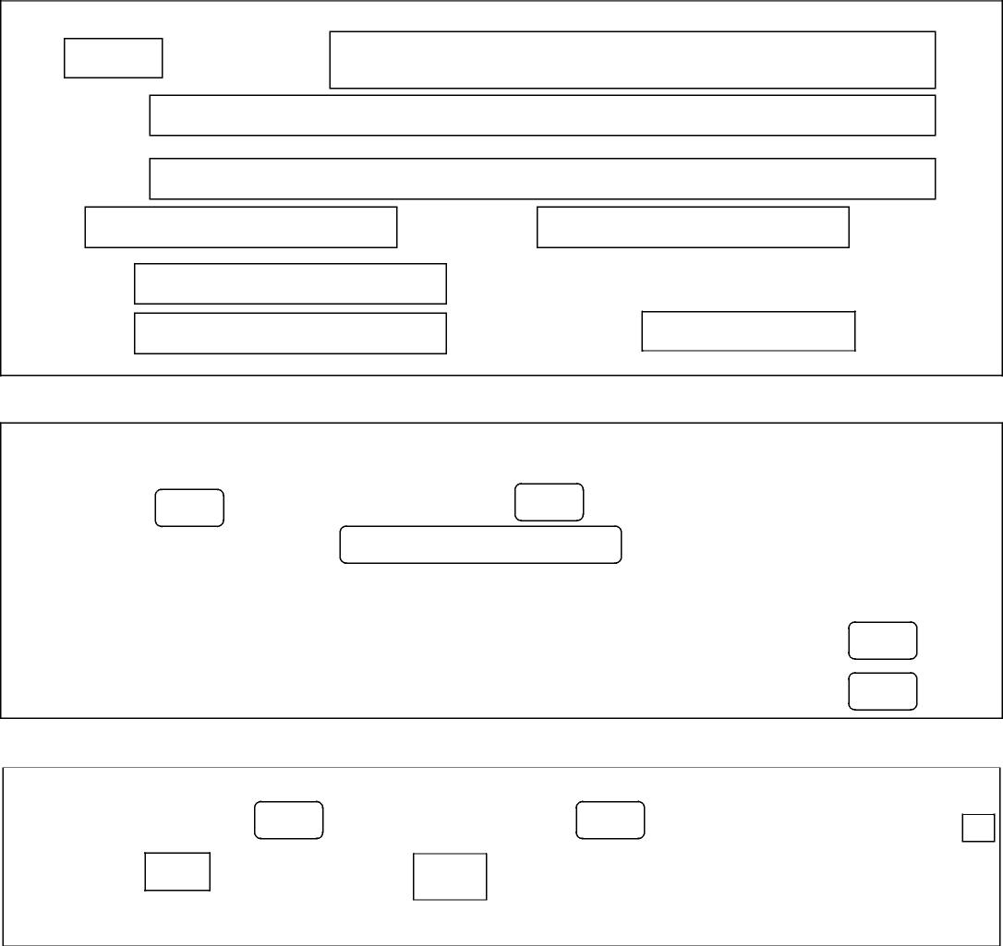
Disabled £nil
Life £nil
Full Name
PERSONAL DETAILS
Title
Address
County
Telephone E-mail
Post Code
Date of Birth
MEMBERSHIP DETAILS
New Member
Current/Previous Member
Archery GB Membership Number ATTACHMENTS
Either a copy of Archery GB Direct Membership Application Form (2020/21)
Or a copy of your Archery GB Membership Card (2020/21)
MEMBERSHIP FEES
Senior Membership £5 Senior Under 25 £2.50 Junior Membership £1.50
Please make Cheque payable to "DWAA" (or Bank Transfer to sort code 20-45-45, account 53620050)
Ralph Wood, DWAA Treasurer, 67 Penn Hill Avenue, Poole, BH14 9LY

