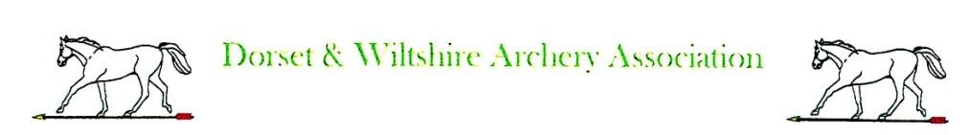
Expenses Claim Form

Name ___________________________________

Post ___________________________________

Date ___________________________________

Expenses Claim Form

Name ___________________________________

Post ___________________________________

Date ___________________________________

Travel Car @ p/mile

Bus Fares

Rail Fares
_________ Miles £____

£____

£____

Travel Car @ p/mile

Bus Fares

Rail Fares

_________ Miles £____

£____

£____

Miscellaneous ______________________________£____

______________________________£____

______________________________£____

______________________________£____

______________________________£____

______________________________£____

______________________________£____

Miscellaneous ______________________________£____

______________________________£____

______________________________£____

______________________________£____

______________________________£____

______________________________£____

______________________________£____

GRAND TOTAL CLAIMED £____

Please complete the form, attach receipts and send to Tony Newland, DWAA Treasurer,
3 Magister Road, Bowerhill, Melksham SN126FD

GRAND TOTAL CLAIMED £____

Please complete the form, attach receipts and send to Tony Newland, DWAA Treasurer,
3 Magister Road, Bowerhill, Melksham
SN12 6FD

If this is your first claim, please provide your bank details for direct payment. Sort Code ___-___-___;

Account Number ___________________

If this is your first claim, please provide your bank details for direct payment. Sort Code ___-___-___;

Account Number ___________________

