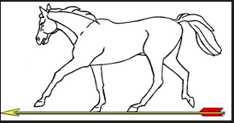

Calling Notice – DWAA AGM – Sunday 12th November 2023 at 1pm at Tesco Extra, The Bourne Centre, Southampton Road, Salisbury Wiltshire, SP1 2NY

In accordance with the constitution, section 17* of the Association, notice is hereby given to all Club Secretaries and Associate members, calling The Annual General Meeting for 2022-2023 (the previous AGM for 2021-2022 being duly held on Sunday 23rd October 2022). Attached are the AGM Agenda, Nomination form and Draft Previous Minutes.

AGM Pre-Registration
If you are planning on attending the meeting, please can you confirm by email to janeprior1511@gmail.com no later than the 4th November 2023, so that provisions can be made for the buffet lunch and refreshments, that we will be providing.

Committee Roles:
If you are interested in volunteering for any of the Committee roles, please arrange to fill out the nomination form also attached and send by email to Jane Prior – janeprior1511@gmail.com no later than Saturday 4th November 2023.

Details of the Committee roles can be found using this link - https://www.dwaa.org.uk/roles/
Current Committee members can be found here - https://www.dwaa.org.uk/committee/

If you have any question, please let me know.

Jane Prior
DWAA Secretary

