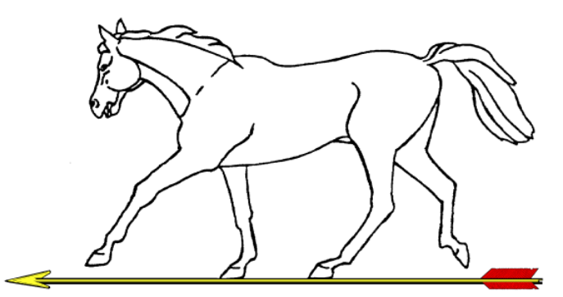 |  |  | DWAA Double WA70/60/50  World Record Status  on  Sunday 12th May 2024
 | Prospectus
Location |  | Hosted by South Wilts Archery Club at: The Trafalgar School, Breamore Road, Downton, Salisbury SP5 3HN
Round(s) |  | Double WA70/60/50 (No Single round entries)  Recurve – 2 x 6 dozen arrows at 70m on 122cm Face (U18 & Master at 60m on 122cm Face)  Barebow – 2 x 6 dozen arrows at 50m on 122cm Face  Compound – 2 x 6 dozen arrows at 50m on 80cm 6 Zone Face  Longbow – 2 x 6 dozen arrows at 70m on 122cm Face (U18 & Master at 60m on 122cm Face)
Date |  | Sunday 12th May 2024
Guest of Honour |  | TBC –
Judges |  | Chairman of Judges: Nick Nicholson  Assisted by: Paul Burden
Registration |  | From 08:00 Please have your valid membership card available for inspection
Entry Fee |  | WA720 Double - £17
Event Timing |  | Equipment Inspection from 08:15 at Judges tent  Assembly 08:45, Practice 09:00 (2 ends), Shooting 09:30
Event Format |  | All bosses will be layered foam bosses  4 archers per boss for all rounds  All shooting will be in timed ends of 6 arrows in 4 minutes, in 2 details.
Awards |  | DWAA Medal Policy (unless otherwise stated).  Recurve Team of 4 archers must include 1 lady or 1 gent and 3 must be seniors.  Mixed Team of 4 archers must include 1 lady or 1 gent and 3 must be seniors (2 recurve and 2 compound)  Compound team of 4 archers must include 1 lady or 1 gent and 3 must be seniors.
Dress Code |  | All competitors must comply with Archery GB dress regulations. Any archer not complying with these regulations will not be permitted to shoot.  See Archery GB Rules of Shooting Rule 307 for details
Drug Testing |  | Archers competing at record status tournaments may be liable for drug testing. Competitors who are approached to provide samples must comply. Failure to do so will be treated as a positive result. Parents / Guardians must sign the relevant box on the entry form to give consent for under 18s to be drug tested if approached
Refreshments |  | Snacks and drinks will be available throughout the day from the catering tent.
Photography |  | Anyone wishing to take photos or video at the event must sign the register first
Car Parking |  | On Site Car Park
Lost Arrows |  | The venue is a school playing field and all arrows MUST be accounted for. All lost arrows must be reported to a judge.  It is the archer’s responsibility to locate any missed arrows before leaving the field. If you intend to shoot all carbon arrows, you must indicate with your entry how you intend to find them should you miss the target.
Dogs |  | No dogs are permitted on the sports premises except assistance dogs which must have a harness and kept on a lead at all times.
Smoking |  | Please use the designated smoking area, well behind the refreshment tent. This includes E-cigarettes
Liability |  | Please be aware that neither GWAS, DWAA, nor the owners of the venue accept any liability for any loss, damage or injury incurred at this event / location, howsoever caused.
Please Note |  | When you enter competitions the following information may be collected and shared with tournament organisers, scoring systems and other competitors and retained for 12 months after tournament. For example target lists and results may be published: First Name, Surname, Gender, Bow style, Date of Birth / Age category, Email, Address, Phone number, Club (and ID), County (and ID), Region (and ID), Round (unless defined by age), Disabled (Y/N), Disability info.
Payment |  | Please arrange to send a BACS payment to: Sort Code: 30-97-41 Account Number: 00314628 Account Name: "South Wilts Archery Club Ltd" with reference being name of archer shooting.
Tournament Organiser |  | Tom Godson Address: 8 West Street, Fordingbridge, Hampshire, SP6 1JH Tel 07534 587294 Email tom.swac@gmail.com

